**NAME:** Mazen Abdelrahman Abdelkhalik Gamil

**B.N:** 630

**DATE:** 6/6/2021

**TOPIC:** Programming language

**Application prief**

This application took about programming language , it is importance in programming devices and its types

Like python and kotlin

**1.**Python continues to be one of the best programming languages every developer should learn this year. The language is easy-to-learn and offers a clean and well-structured code, making it powerful enough to build a decent web application. Python can be used for web and desktop applications, GUI-based desktop applications, machine learning, data science, and network servers. The programming language enjoys immense community support and offers several open-source libraries, frameworks, and modules that make application development a cakewalk. For instance, Python offers Django and Flask, popular libraries for web development and TensorFlow, Keras, and SciPy for data science applications. Though Python has been around for a while, it makes sense to learn this language in 2020 as it can help you get a job or a freelance project quickly, thereby accelerating your career growth.

**2**.Kotlin is a general-purpose programming language with type inference. It is designed to be completely interoperable with Java. Moreover, from the time Android announced it as its first language, Kotlin offers features that developers ask for. It effortlessly combines object-oriented and functional programming features within it. 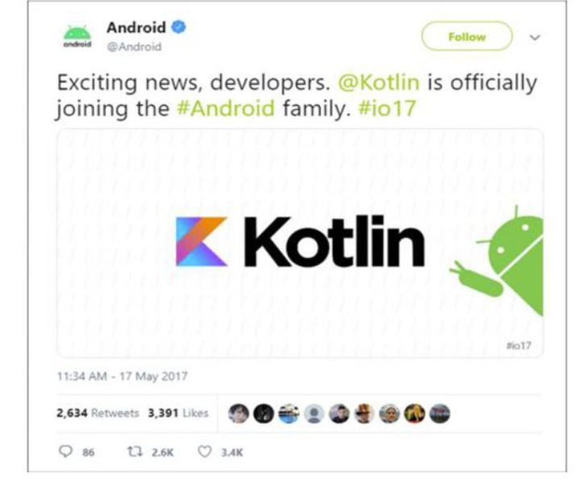 The effortless interoperation between Java and Kotlin makes Android development faster and enjoyable. Since Kotlin addresses the major issues surfaced in Java, several Java apps are rewritten in Kotlin. For instance, brands like Coursera and Pinterest have already moved to Kotlin due to strong tooling support. As most businesses move to Kotlin, Google is bound to promote this language more than Java. Hence, Kotlin has a strong future in the Android app development ecosystem. Kotlin is an easy-to-learn, open-source, and swift language for Android app development that removes any adoption-related barriers. You can use it for Android development, web development, desktop development, and server-side development. Therefore, it’s a must-learn language for programmers and Android app developers in 2020.

I chose this application because it’s informations is easy to reach

Screenshots/

1.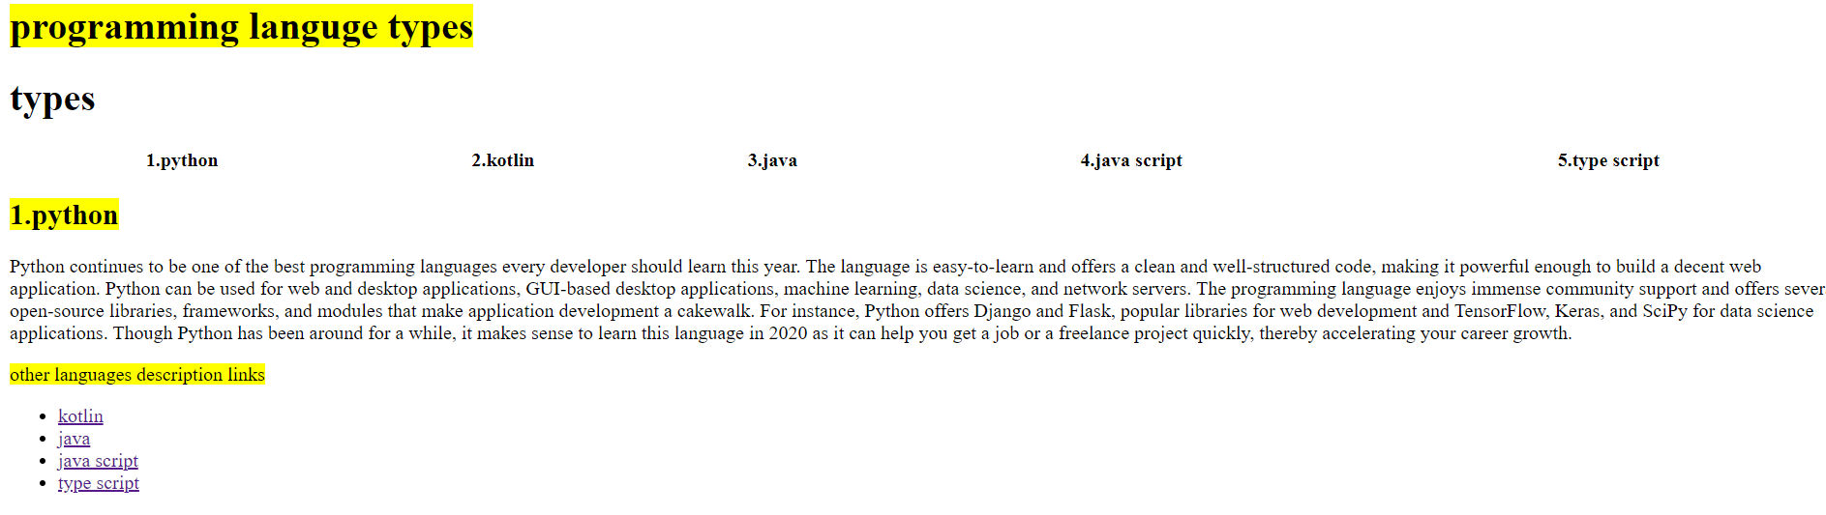

**2.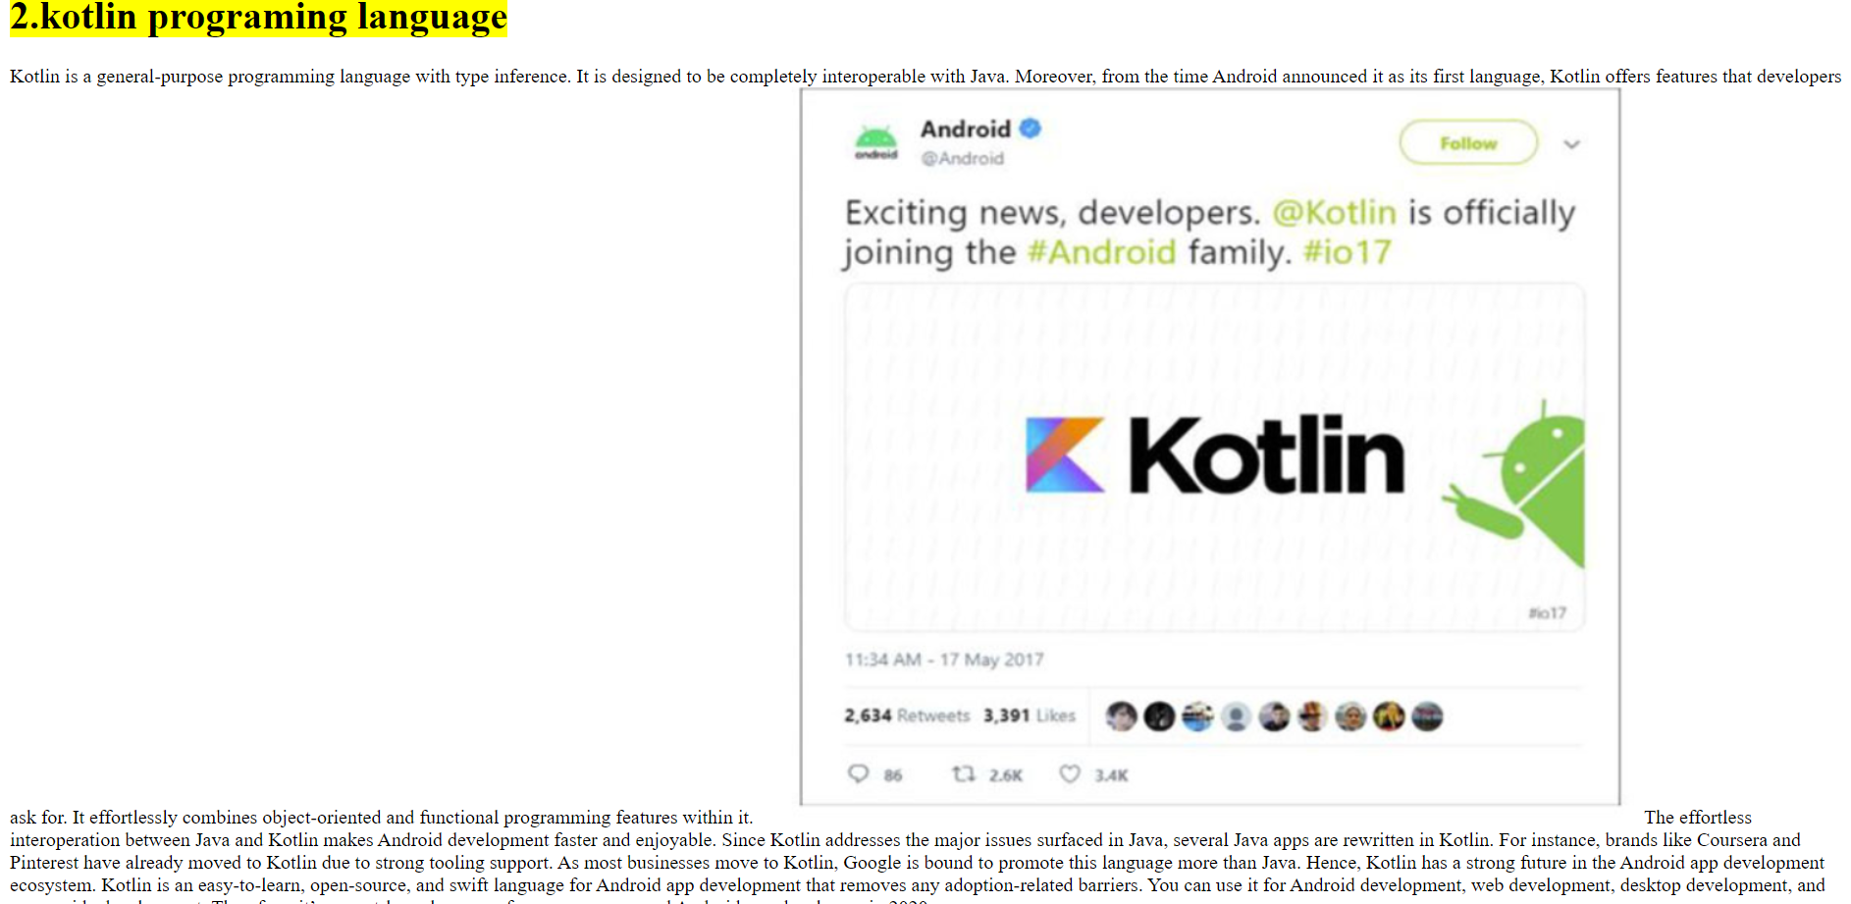3.**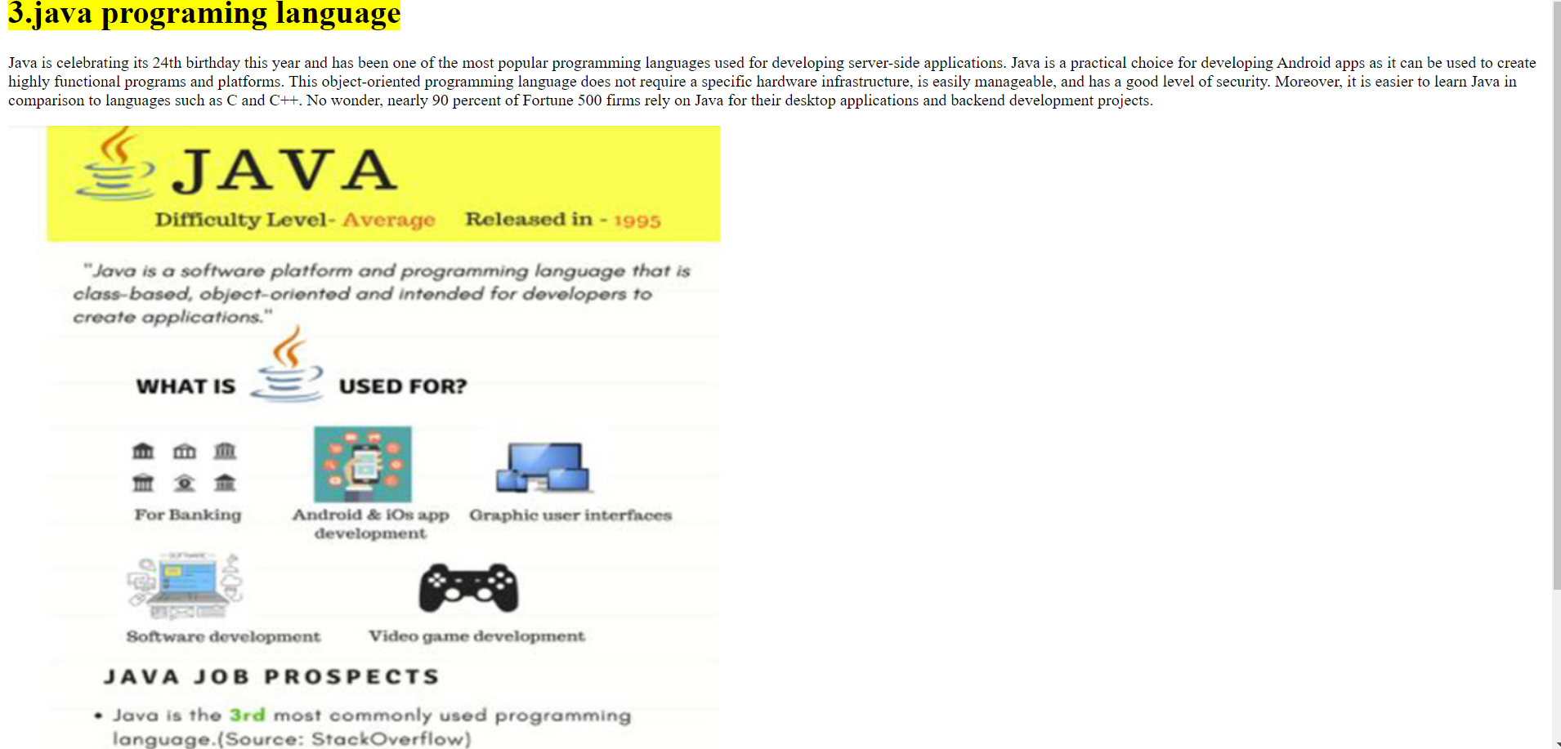

**4.** 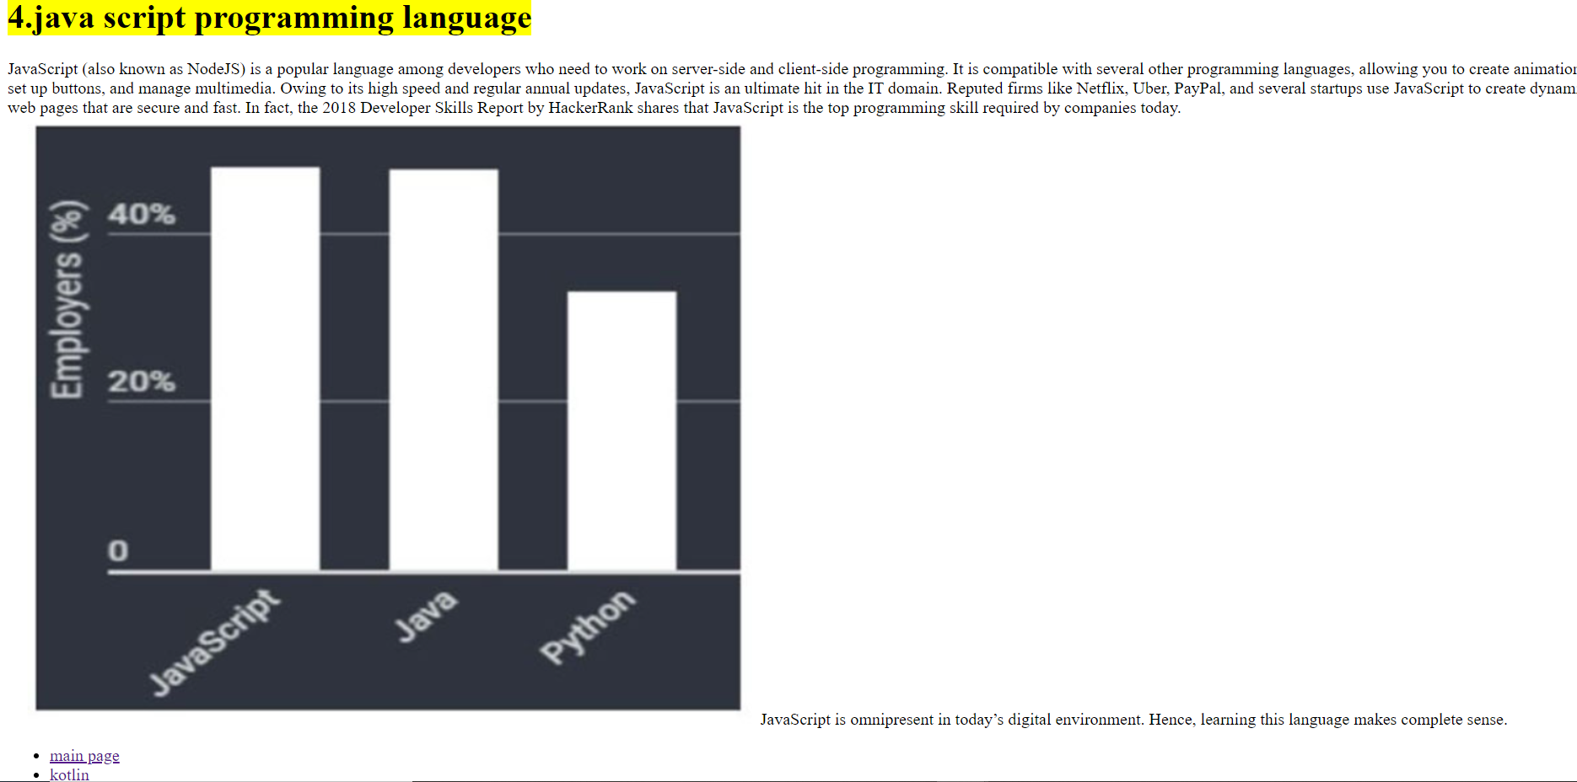

**5.** 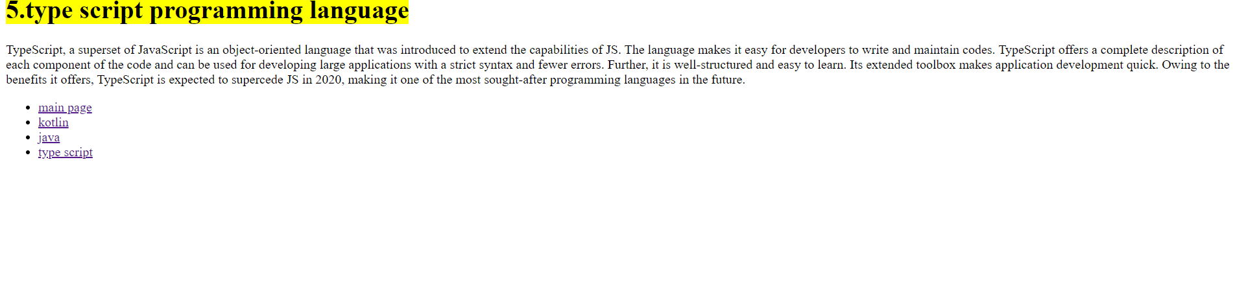

**Source code/**

1. 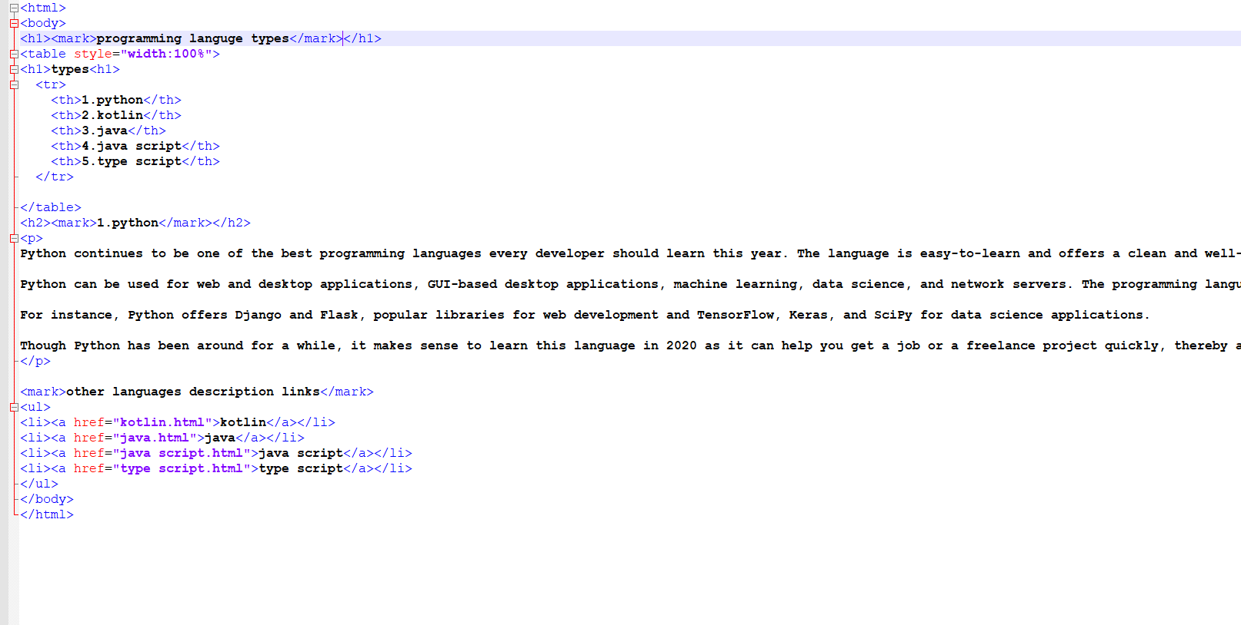
2. 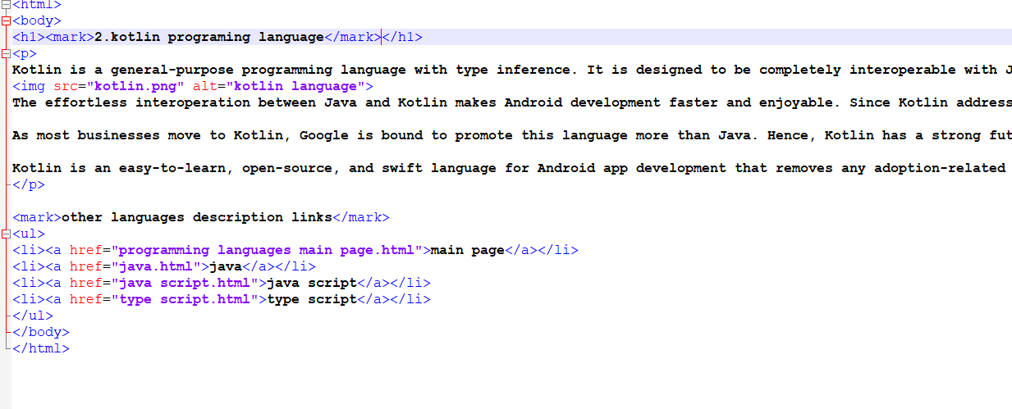
3. 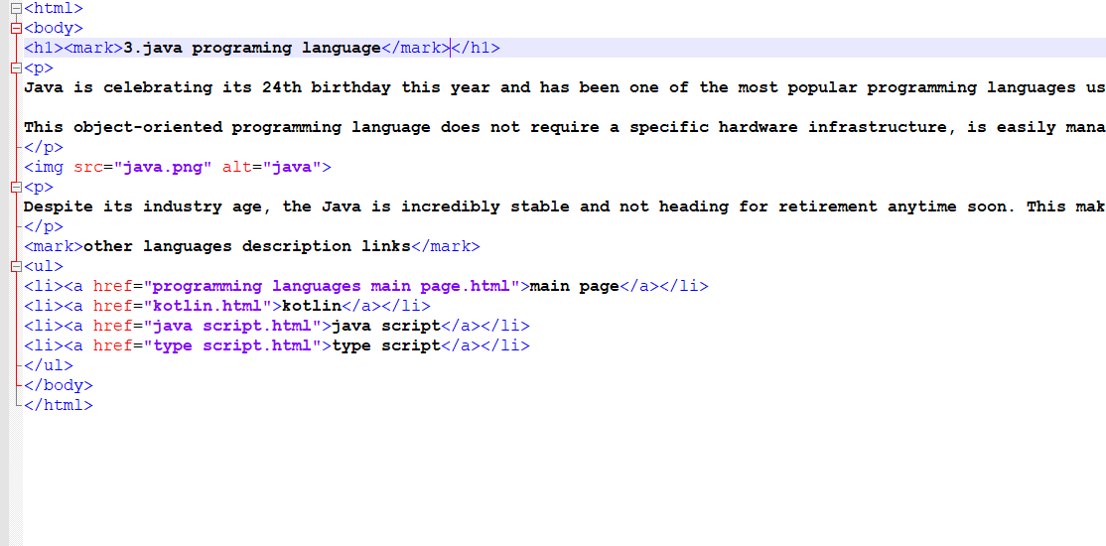
4. 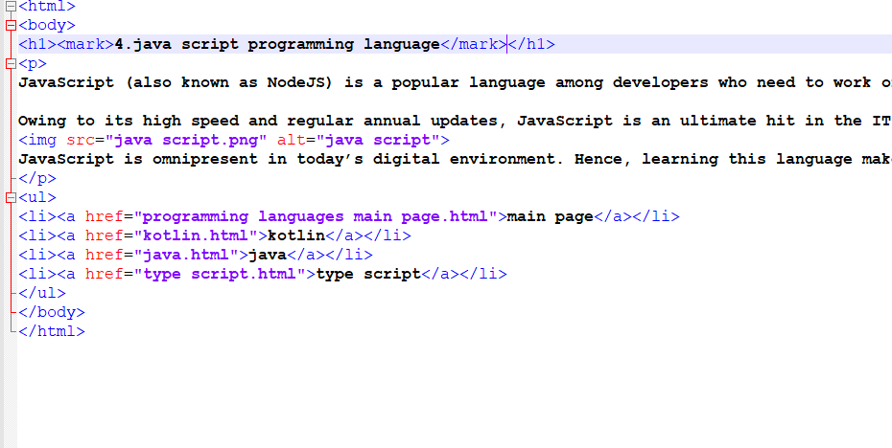
5. 